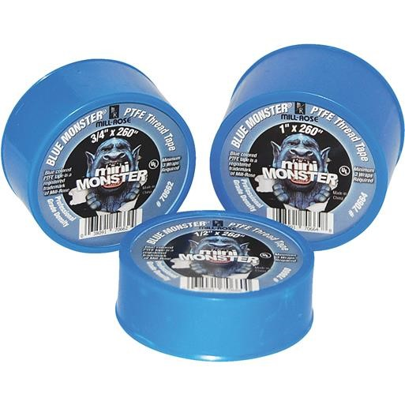

* Acids, concentrated (see precautions)
* Acids, dilute
* Alcohols, Gasohol
* Aliphatic solvents, Aromatic solvents
* Chlorinated solvents
* Ammonia, liquid
* Caustics, concentrated (see precautions)
* Compressed air, Steam, Water
* Cutting oils
* Diesel fuel oil
* Ethylene glycol, Glycerin

Blue Monster Tape

(Available in ½” and 1” sizes)

* Fatty acids
* Heating oils, Kerosene
* Hydraulic fluids, Hydraulic oils
* Hydrogen gaseous and liquid
* Inert gases, gaseous and liquid
* Jet fuel
* Ketones, Petroleum solvents
* Liquid Petroleum Gas, Natural gas
* Mineral oils, Vegetable oils
* Nitrogen, gaseous and liquid
* Soap, liquid